TQM (Course Outline)

XIM, BHUBANESWAR
Instructor : Bijoy Dash (bijoydash@nalcoindia.co.in)
PGP II : 2003-2005
TERM V: (13 Sept. to 20 Dec. 2004; End Term : 15-20 Dec. 2004)
(Class meets from 6.00p.m. to 7.30 p.m. on Tuesdays and Thursday)

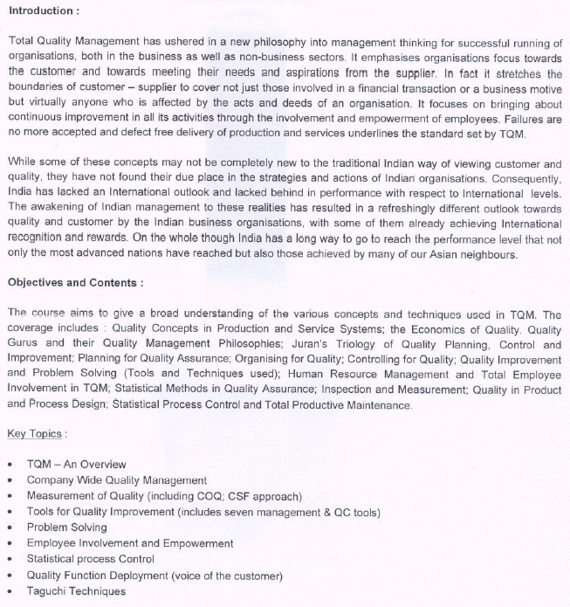
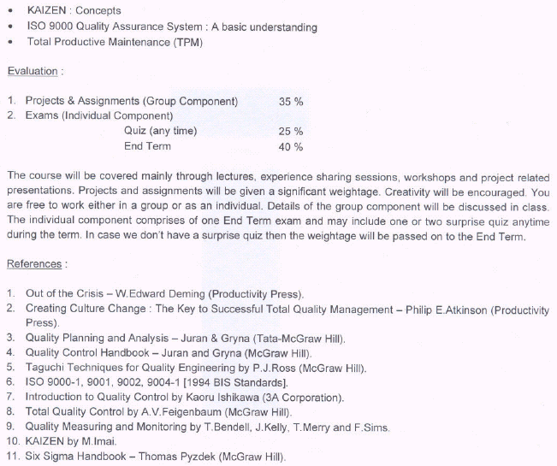
TQM (Session Plan)

XIM, BHUBANESWAR
Instructor : Bijoy Dash (bijoydash@nalcoindia.co.in)
PGP II : 2003-2005
TERM : (13 Sept. to 20 Dec. 2004; End Term : 15-20 Dec. 2004)
(Class meets from 6.00p.m. to 7.30 p.m. on Tuesdays and Thursday)

Session | TOPICS | READINGS/ REFERENCES
Session 1  Session 2  Session 3 | TQM CONCEPTS AND OVERVIEW  - Understanding Quality  Five Approaches to Defining Quality  - Quality in Facts & Perception  - Historical Overview and Emerging Trends  - Quality Gurus and their Approaches  - Quality of Design Vs Quality of Conformance  - Push-Thru’ Vs Pull Thru’ systems  - Juran’s Quality Trilogy  - The 3 Focus areas of TQM  - QUALITY MANAGEMENT PRINCIPLES | - Text : Chapter 1  - “What does Product Quality Really Mean? - David A Gavin  - “A Note on Quality : The Views of Deming, Juran and Crosby” - Harvard Business School.  - Text : chapter 5  - ISO 9000:2000 Standard  - Class Notes  - Reference : “Quality Control Handbook” - Juran and Gryna
Session 4  Session 5  Session 6 | CUSTOMER FOCUS  - Customer Concepts - Who is a Customer  - Voice of The Customer  10 Commandments of Good Customer Service  Vs Mahatma Gandhi’s 5 Golden Principles  - Measuring Customer Satisfaction –  Complaints Vs Satisfaction  Customer Satisfaction Vs Delight  - Customisation/ Mass Customisation  - Service Quality considerations  - Quality Function Deployment | - Text : Chapter 3  - Class Notes  - Text : Chapter 15  - “Adding Zip to Product Development : Concurrent Engineering Methods and tools” - Morgan L Swink
Session 7  Session 8  Session 9 | PROCESS FOCUS  - Genesis of Process Focus  Quality Control to SPC/ CWQC/ TQM  - Control Vs Improvement  - ISO 9000 in Process Standardisation and Improvement  - Process Capability and Six-Sigma  - Taguchi Loss Function  - Business Process Benchmarking  - FMEA/ FMECA  - Process Improvements & KAIZEN  - Improvements to Innovation  - POKA-YOKE | - Text : Chapter 10  - ISO 9000:2000, ISO 9001:2000  - ISO 9001 AP Group – Sydney Model  - “A Note on Quality: The Views of Deming, Juran and Crosby” - HBS  - Text : Chapter 5  - “The Evolution of Six Sigma” - Jim Folaron  - “DOE : A Potential Analytical Tool” - Christopher Nachtsheim  - Text : Chapter 8  - Text : Chapter 14  - Text : Chapter 5
Session 10  Session 11  Session 12 | TOOLS FOR QUALITY CONTROL/ IMPROVEMENT  - Juran’s Diagnostic-Remedial Journeys  - P-D-C-A / QC Story / DMAIC  - Organised Problem Solving  - PS TOOLS  - Brainstorming  - Basic 7 Tools  - 7 Management Tools  - Force Field analysis; Risk Analysis | - “Quality Control Handbook” _Juran & Gryna  - “Continuous Improvement : Methods and Madness” – A J Peterson & R J Reid  - “How to Measure Continuous Improvement” - D K Wetzel & G P Manul  - Quality Improvement Tools  (Text : Chapter 17 & 18)  - Class Notes
Session 13  Session 14 | TOTAL PRODUCTIVE MAINTENANCE  - What is TPM  - Genesis of TPM and Hienrich’s Triangle  - Six Major Categories of Losses  - Pillars of TPM  - Jishu Hozen(Autonomous Maintenance)  - Kobetsu Kaizen (Focused Improvement)  - Other Pillars  - TPM Vs TQM | - Text : Chapter 16  - “ How is TPM Different?” - Terry Wireman  - Class Notes
Session 15  Session 16 | QUALITY MEASUREMENT  - Why Measure Quality Costs?  - The 3 Ms – Muri (Strain), Mura (Discrepancy) & Muda (Waste)  - Cost of Poor Quality  - Quality Excellence Models | - “The Tip Of The Iceberg” - J A DeFeo  - “ COQ : Which Collecting System Should be Used?” - Gary Zimac  - “Quality is Free” – Phil Crosby
Session 17  Session 18 | PEOPLE FOCUS  - Soft Vs Hard Route to Quality  - Employee Involvement & Competency  - Empowerment  - Role of Quality Circles  - Overview of BPR
Sessions  19 and 20 | To accommodate Spillovers due to activities related to Interactions/ Case Studies  Project Proposals and Guidelines
15-20 Dec ‘04 | END TERM EXAMS (CLOSED BOOK)

Text: Total Quality Management - by Dale H. Besterfield and others. Pearson Education, 3rd. Edition, 2004.

