Instrumental case: the Perfect Pineapple Supply Chain Programme
Background
The Perfect Pineapple Supply Chain Programme was initiated in late 2003 and involved an Australian canned pineapple supply chain stretching from growers/ through transport links and a processing plant/ to a major retailer (see Figure 7.3). The supply chain also involved three key suppliers of cans/ cartons and pallets.

The programme centred on a company processing 110/000 tonnes of fresh pineapple every year through a single facility. The majority of processed fruit is canned either in slices (or rings)/ pieces/ cut (small pieces)/ crush, or pulp for juice.

The company was set up as a cooperative in 1946/ and is owned by about 700 fruit and vegetable growers - with the majority of shares held by 171

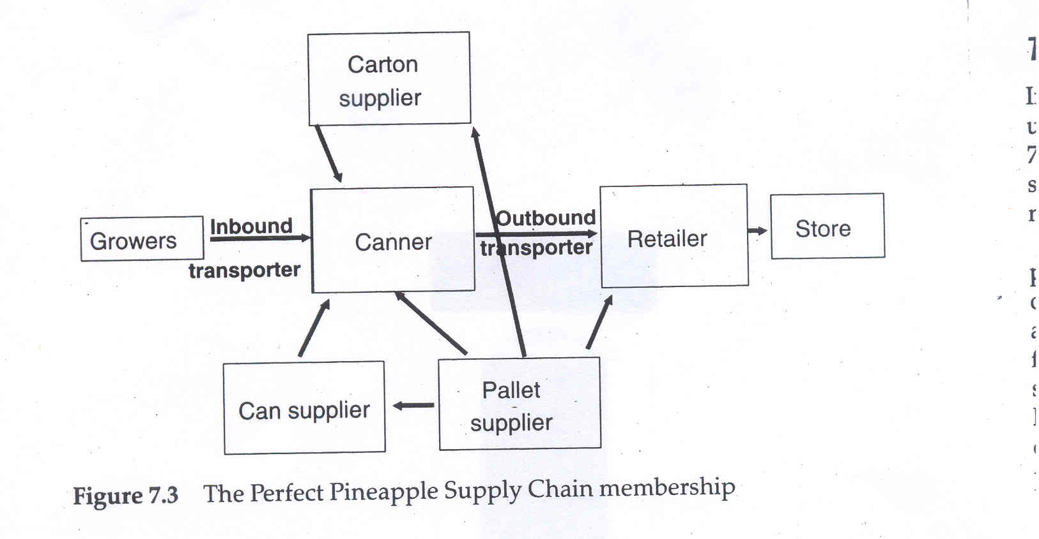

pineapple growers. The company is Australia's largest grower-owned fruit and vegetable processor/ with pineapple products representing 20 per cent of turnover. The market for these products is largely domestic and is dominated by Australia's two major supermarkets/ who control 80 per cent of the market one of whom took part in this study. The recent history of Australian supermarkets has been one of consolidation and emulation of overseas best practice and, in common with other markets/ power in the Australian food industry seems to reside at the retailer/ with relationships in the supply chain generally exhibiting low levels of trust (Sadler and Hines/ 2002; Simons et al, 2004).

The retailer involved in the work was in the process of establishing a new supply chain strategy including:
• the development of a primary freight system/ which is an Australian version of factory gate pricing (IGD/ 2002; Potter et a\, 2003) involving retailer-controlled collection/ cross-docking and revised distribution centre configuration;
• store-friendly one-touch replenishment involving a streamlined material and information flow in the supply chain with the ideal of touching product only once between point of manufacture and checkout (Jones and Simons/2000);
• vendor to store shelf end-to-end process efficiency and integration;
• the development of supplier relationships;
• delivery of cultural change and breakdown of functional silos.
At the start of the programme, there was limited evidence that the retailer had succeeded in implementing this new strategy.
The programme
In late 2002 the processor started a programme of manufacturing change under the a newly appointed general manager. The first year (step 1 of Figure 7.4) involved a series of improvement initiatives at the main manufacturing site. This included value stream mapping and a series of smaller improvements to internal and external information flows.

During this period it became apparent that many of the issues and problems faced by the company were the result either of actions taken by other organizations or of a lack of complete supply chain coordination. In addition/ the company was suffering rapidly declining profits/ reporting its first ever loss in 2003. At the same time/ its major customers were increasing shelf space to imported product/ including canned pineapple from the Philippines. As a result it was decided to widen the scope of the programme to encompass the wider supply chain. Focusing on canned pineapples, the programme was christened the Perfect Pineapple Supply Chain Programme.

Step 2 of the programme brought together senior executives from the different firms involved to establish what the supply chain looked like and what the programme could achieve/ and to gain a commitment from the companies to take part in the programme. During this meeting the major issues facing the supply chain became clear. The managing director of the processor commented on the pressure exerted by retailers/ particularly in terms of costs. This was particularly relevant as the company was losing market share to overseas competitors whose product retailed at 30 per cent lower prices. It would be difficult for the company to absorb these reduced margins ~ so they put pressure on growers, who had not received an increase

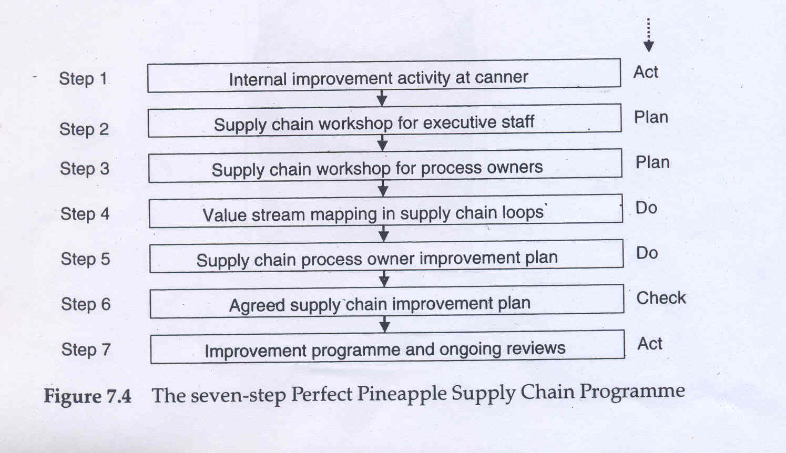

in price for their pineapples for nearly 10 years. The managing director concluded with the view that the only way forward was to work together as a team for everyone's mutual benefit. This view was generally accepted/ but there was concern that some - primarily the retailer - would gain more than others/ or even at the expense of the other participants.

The meeting included an exercise to map the whole supply chain. This showed that no one had a good picture of the complete supply chain/ and few could describe the operations within their own business in great detail. The meeting also developed an ideal future state - as well as the barriers to getting there. These barriers included capital shortages/ problems it changing culture/ skilled people to make the change/ the older age of growers/ the lack of integrated IT/ and the processor's lack of an explicit strategy.

Step 3 was to bring together the supply chain's process owners/ or operational staff. This was done shortly after step 2/ with meetings following a similar path to those of the executive group/ except that less time was spent discussing what was required and more on how it might be done. A far more detailed map of the supply chain was developed/ and with it the real problems began to emerge. Agreement was reached to undertake a more detailed analysis of the supply chain in five loops involving cross-company groups. The loops were a downstream loop (post-manufacture)/ a canning loop/ an upstream fruit loop (up to delivery of pineapples) and two loops for the cans and cartons respectively. The result of this step was an agreed outline plan for each loop. These plans were presented back to the executive group.

Step 5 had discussions among the executive group of the findings and recommended projects - and how these could be developed into a workable plan. The view of the retailer was that they were keen to develop a new/ closer relationship with suppliers-but would do so only in a step-by-step approach and only with like-minded firms.

The discussions quickly identified short-term gains of A$3-4 million/ although further analysis showed that the true benefits could be of the order of A$20 million. However/ two areas of concern emerged. The first was that it was difficult to plan a supply chain transition/ as a new strategic plan for the processor was being finalized over the next three months. The second was the fact that all the firms were actively taking part, but not all seemed to be fully committed. In particular/ concerns were raised about the can and carton makers who were only able to identify savings of less than A$100/000 each. However/ they soon changed their stance and agreed a strategic review involving an analysis of the type of packaging used and how this might be changed - for example/ from cardboard boxes to plastic bins.

As a result of these discussions/ various uncomfortable issues were brought to the surface/ and hidden and unspoken concerns were shared. The result was that the atmosphere changed from being unsure to very positive. This positive feeling was reinforced by a strong plan involving all the respective firms in its delivery. The top level of this plan is shown in Figure 7.5.
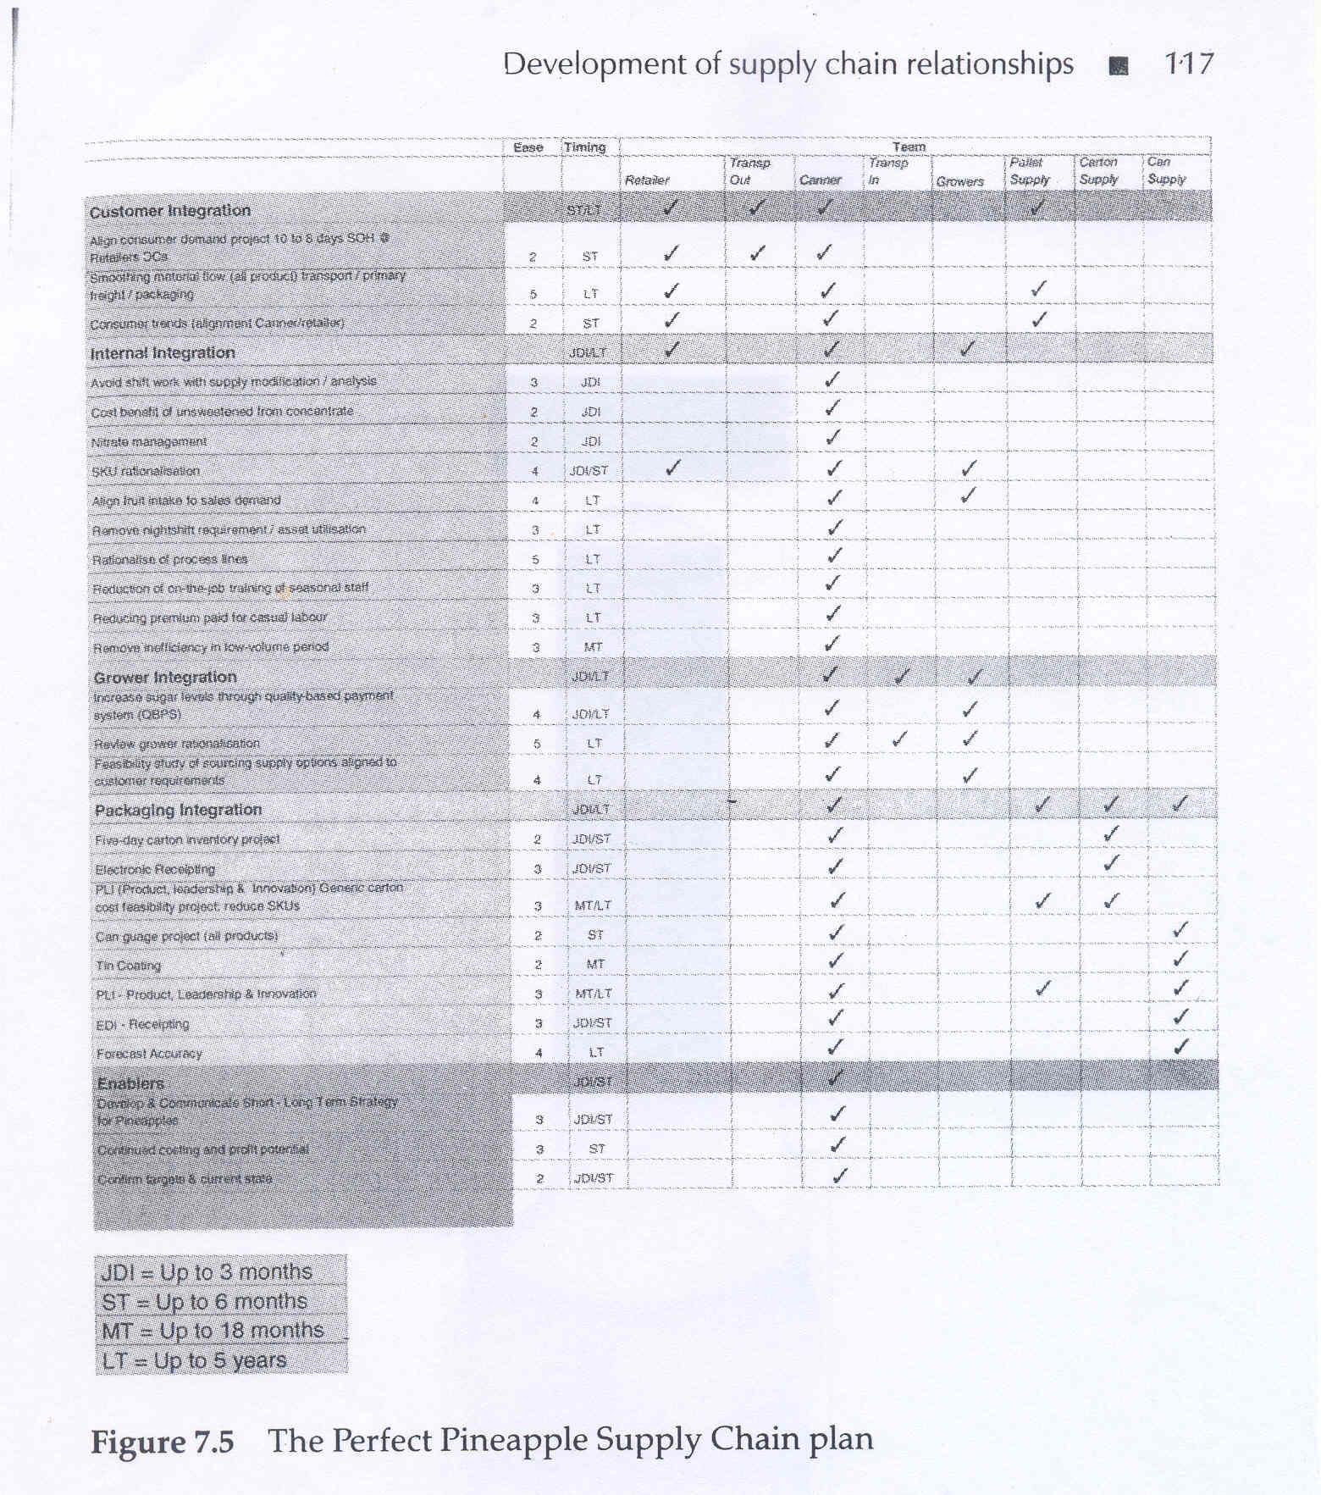

Since this point the group has continued implementing the plan and has already gained benefit of several million dollars. As a result/ the processor has decided to extend the scope of the work to include a further loop -namely a beetroot loop/ which represents a further 15 per cent of turnover. This step is a prelude to the development of further loops (for example/ for baby food raw material ingredients/ and fruit or fruit concentrate for fruit juice). It was also decided that once these further loops were in place (in late 2005) the extended group of companies (ie members of the Perfect Pineapple group and members of the new loops) would come together periodically and take on the shape and dynamics of a true supplier association (Hines/1994).
Explanation and discussion
To explain what was happening within this case/ a simple two-phase development model is presented/ primarily in terms of changes at a macro level to the risk and trust that the food processor had developed with (but also to some degree between) members of the Perfect Pineapple Supply Chain Programme.
Phase 1 explanation
During the early stages of the work the processor was attempting to g commitment by increased knowledge transparency/ starting to increase competence levels and attempting to set up a common-destiny relationship set. In the process they were seeking to move away from historical contractual relationships (or what Sako (1992) terms a contractual trust relationship) that carried a varied but generally low level of trust and resulted in a high level of risk for all involved (phase 1 in Figure 7.6).

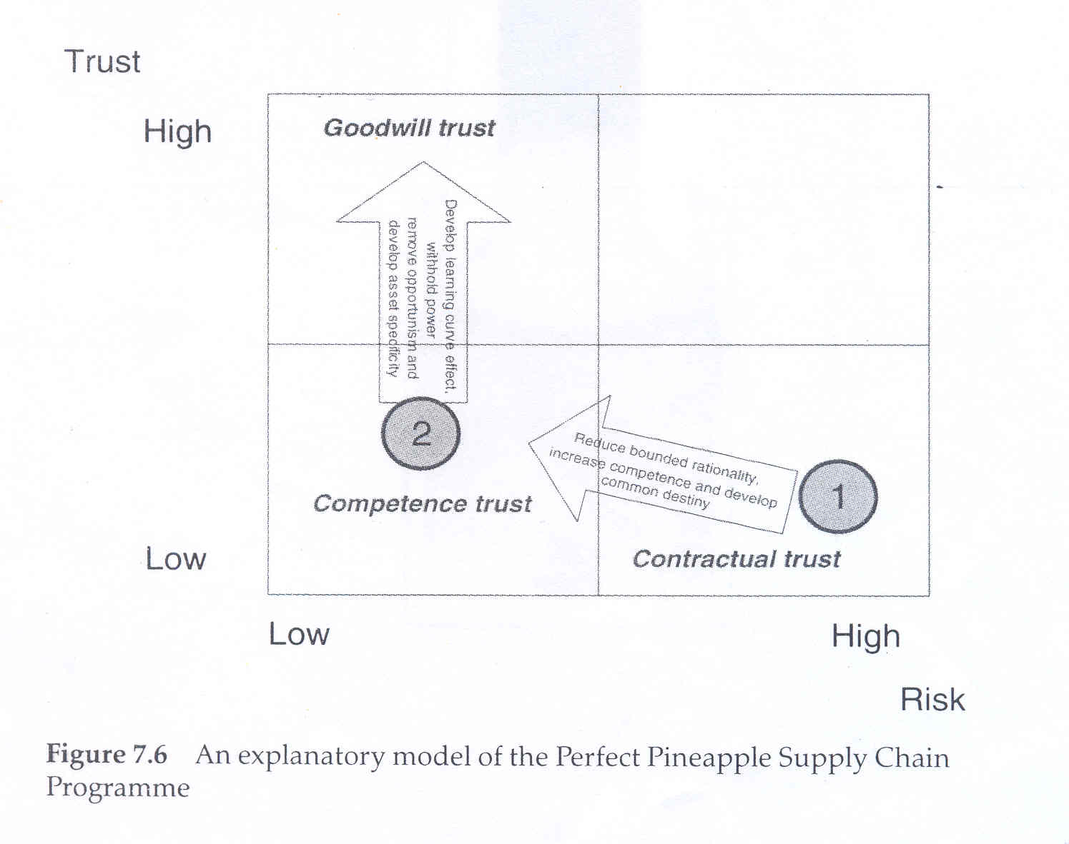

Specifically, they were creating an open forum for exchange of views and information. This process involved identifying common (or not common) issues/ concerns and visions for the supply chain/ as well as the mapping of the complete chain by cross-company groups. This mapping also increased the individual and collective competence of the group/ both in their own area and in the remainder of the supply chain. As a result/ various individuals could see the bigger picture and the roles of others in improvement projects. In addition/ this increase in individual and collective competence was likely to increase costs for new supply chain entrants/ increasing barriers to entry and reducing risk for the present firms.

In this phase/ senior staff from the processor went out of their way to develop a sense of common destiny/ both by working to develop common measures across the supply chain and by creating an environment where mutually beneficial plans could be developed by teams from across the supply chain. Further commitment was sought with the full involvement of the retailer/ but it was not yet possible to achieve the full commitment of all -particularly the packaging firms.
Phase 2 explanation
During the second phase of activity (steps 6 and 7)/ the processor was attempting to increase trust/ having gone a significant way to reducing risk for all those involved. This second phase involved the development of learning effects/ withholding power/ and the removal of opportunistic behaviour - and ultimately was leading towards increased asset specificity- In terms of the explanatory model/ the processor was seeking to move beyond competence trust to achieve goodwill trust/ with firms doing more than their explicitly stated commitments (phase 2 in Figure 7.6).

Staff at the processor worked hard to ensure that a place in the improvement work could be found for all of the firms. In addition/ they developed an approach that was sustainable/ as it was not focused on quick wins/ but a longer approach of at least three years' duration. Even at the early stages of the work they held informal discussions about developing the programme into a supplier association programme.

The second phase also involved the development of withheld power with a common set of metrics and attention paid to the fact that all the firms involved needed to see some benefit from the work. An example of the withheld power was the 'quiet word⁷ to packaging firms when they appeared not to be giving their full commitment. They got reassurance that their involvement would benefit their firms and lead to a longer-term relationship with greater profit potential to all involved.

The second phase of activity moved the relationship set from a competence-based trust to the start of a goodwill trust where individual actors are starting to do things for the common good of the group rather than their individual benefit. This type of two-phase development has proved to be beneficial to the firms involved/ but it may not be suitable in all other environments. It was .appropriate here because the environment involved:
- regular repeated transactions (with daily or weekly orders);
a the willingness to hold back from explicit power relationships and the use of 'withheld power';
- an agreed common benefit in working together;
- a specific non-commodity product;
- appropriate outside facilitation to make concerns explicit.

Discussion: adding two more variables
In this case all the firms to a greater or lesser degree took an active and positive role in improvement. In addition/ the relationship between the focal food processor and all the other firms improved - as did many of the relationships between the firms. And there are clear explanations for some of the activities and relationships when we view the case through the three different lenses of trust/ risk and power.

However/ we also concluded that/ although each of these lenses is important/ even together they are insufficient to explain the behaviour set. As a result of these observations/ we would like to suggest two further interlinked factors that determined the success of collaboration in this case and may well have an importance in other instances. These are the type of ownership and corporate governance (and resultant governance structure)/ and the individual employee commitment or engagement.

Corporate governance is concerned with the decision made by senior executives of a firm and the impact of their decision on various stakeholder groups and therefore refers to the relationship between the board and the firm. Bradley (2004) comments that the search for the link between returns and governance is the Holy Grail for many practitioners and academics in the field of corporate governance/ and that an ever-growing amount of evidence now exists to suggest that these links do not exist. Nonetheless we would argue that the corporate governance does influence management's approach to, control versus commitment in the workplace.

Walton (1985).identifies these two opposing approaches to a company's human capital and, points out the key challenges in moving from one to another. We would suggest that the firm's progress in this regard is likely to impact the individual predisposition to supply chain collaboration's success. Lucy/ Bateman and Hines (2004) coin the term 'employee engagement⁷/ highlighting its importance to the success of any change initiative. Indeed/ their research suggests that people's degree of engagement is likely to be influenced by a range of personal and corporate objectives that may not be at all obvious at first sight to the casual observer. Supply collaboration invariably involves the reshaping of supply chain partners' patterns of behaviour and therefore demands a high commitment - a function of corporate governance - initially from the leading partner and subsequently from all parties involved.
Applying five lenses to the case
In order to understand the dynamics and relationships within the case study/ it is useful to review the five determinant factors discussed earlier (power/ risk and trust) and in the last section (ownership and governance structures/ and commitment) and see how these have impacted on each of the participating firms. Before doing this/ it is useful to explore how a single-lens perspective may give a misleading or incomplete impression of reality. In order to illustrate the point/ we will take the example of a single power lens as advocated by Cox (2001a/ 2001b, 2001c).

Using a development of Cox's power regime approach we can develop a power map for the physical movement of product (Figure 7.7), with the width of the arrows proportional to the cash flows/ and the figures in circles representing the total business turnover of each firm. Following Cox (2001a)/ the symbols represent:
< buyer having power over supplier
> supplier having power over buyer
== interdependence ,
0 independence

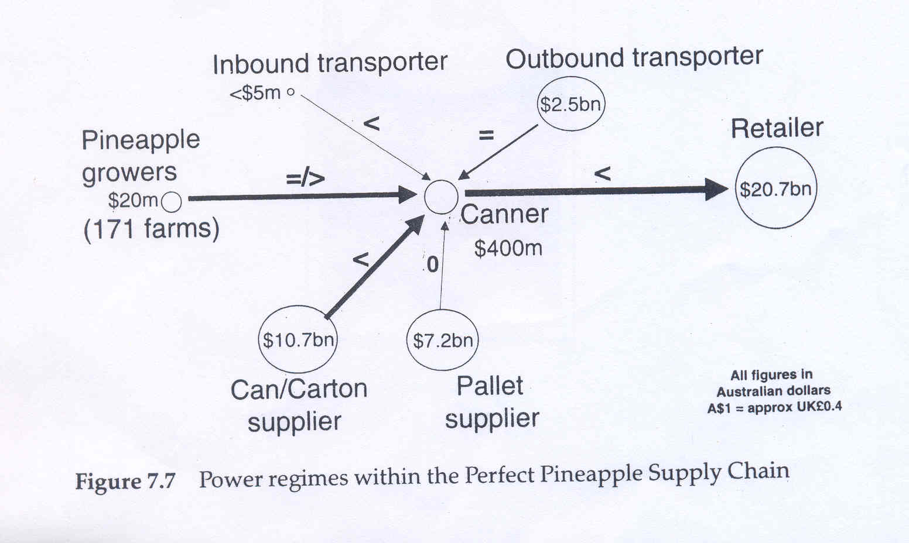
The retailer holds power over the processor/ primarily owing to size and ability to switch to cheaper imported product. The processor holds power over the can and carton maker as well as its inbound transporter. The processor has a relatively interdependent relationship with the outbound transporter and/ owing to their low reliance on each other/ a relatively independent relationship with the pallet supplier. The processor appears to hold power over the growers/ but the governance structures between the two mean that the processor is owned largely by the pineapple growers.

It should be possible to interpret where successful supply chain relationships and development are possible/ and where existing power regimes would preclude their effectiveness. According to Cox/ a supply chain approach will only work where there is buyer dominance or buyer-supplier interdependence. So we can predict that the processor will be able to encourage the transport firms and packaging suppliers actively to take part/ but find it very hard to engage the other firms. However/ a different picture emerged. In gaining agreement and commitment to the programme/ various difficulties appeared/ which could not completely/ or .even largely/ be explained by existing power regimes.

As the programme of activities aligned closely with the retailer's strategic objective/ the retailer was enthusiastic about the programme. In addition/ the growers were enthusiastic because it was ultimately to their benefit for the processor to produce a better financial result. The other company that showed the greatest enthusiasm was the outbound transporter. However/ this owed little to the interdependence it enjoyed with the processor, and more to the perceived threat and risk that it felt in potentially losing business.

In-addition/ the inbound freight firm was not brought fully into the initiative in the early stages - but this was more to do with the commitment levels of the individuals involved/ and once the discussions became more operational there was a much higher level of personal engagement. The pallet firm similarly did not take a very active part - but the reason appeared to be that improvements to the supply chain would probably reduce the number of pallets required. It also seemed that the packaging suppliers were only paying lip service to the work and were offering only marginal benefits. Their lack of involvement can be explained in two ways: firstly/ the individuals involved saw little in the work in terms of career development; secondly/ and more importantly/ they did not trust the processor because of a history of adversarial price reduction demands.

The reactions and involvement of the different companies were sensible and indeed logical from their perspective. However/ their responses cannot adequately be explained simply through a power lens. By viewing each company through each of the five lenses - power and dependency/ risk/ trust/ ownership and governance structures/ commitment - their behaviour can be both understood and explained (see Figure 7.8).

In reality/ each of the five variables had some influence on individual firms behaviours and how engaged they were (highly engaged firms are shown in

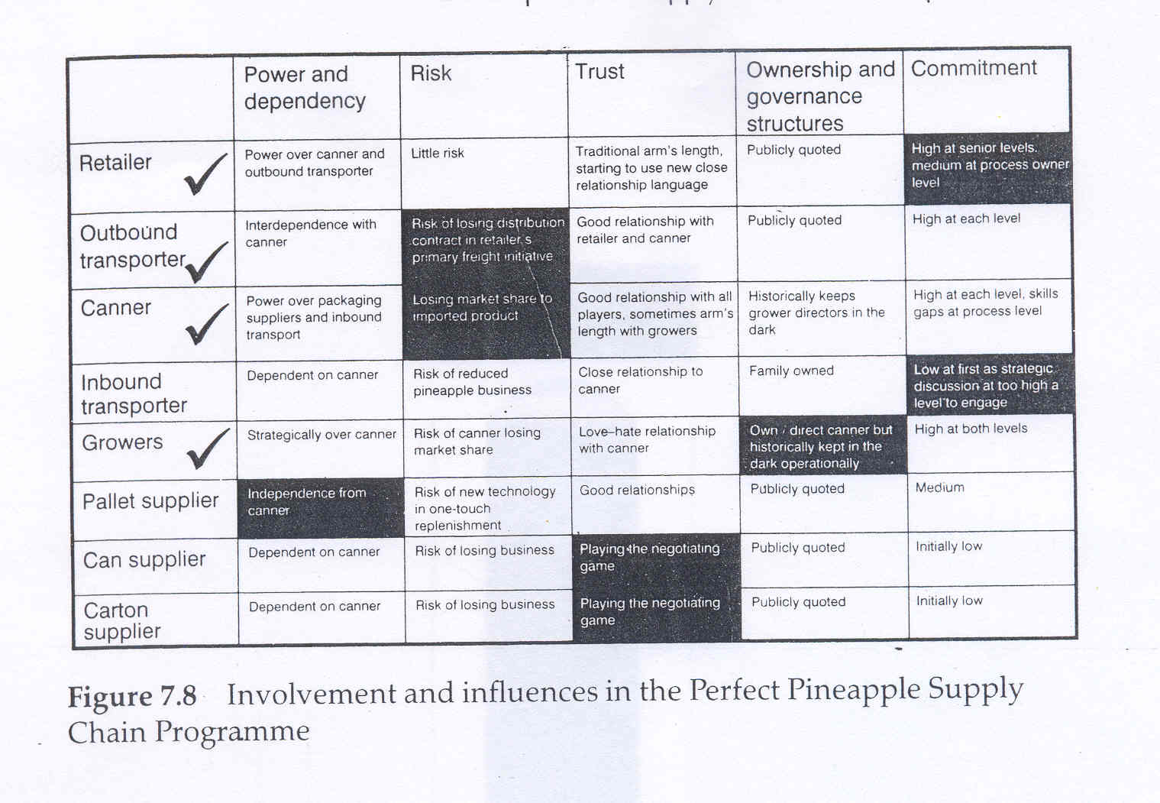

Conclusion Returning to the research questions
We have attempted to address four questions. The first sought to understand how three well-established variables (power and dependency trust and risk) impinge and explain the actions of actors within a supply chain. It has been shown that each of these lenses has proved helpful in understanding the motivation of behaviour. However/ we have demonstrated that none of them/ on their own/ can adequately explain the behaviour of any one of the actors.

Linked to this first question/ the second question was to explore which of the three variables might be more important in shaping the actions of each actor. The analysis presented in Figure 7.8 shows that each of these variables was the single most important factor in explaining some behaviour. Power and dependency was most important for the pallet supplier/ risk was most important for the outbound transporter and the canner/ and trust (or lack of it) was most important for both can and carton suppliers.

Our third question sought to understand whether there are any other important variables in addition to power/ trust and risk. It was clearly established that it was not possible - in this particular case - to explain the behaviour of the firms using the three variables. We found two additional factors that were pre-eminent in explaining behaviour in at least one of the firms involved. These were the ownership and governance structures (most important for the growers) and personal commitment (most important for the retailer).

The last research question was contingent on there being a complex set of explanatory variables at play - which there did indeed prove to be. Gaining a more detailed understanding of the different variables at play might improve supply chain management through better relationships and more effective improvement activities. This was achieved in two ways. First/ an explanatory model was developed (Figure 7.6) to supplement our description of what was happening within the case; second/ a framework was constructed (Figure 7.8) that summarizes the impact of the different variables on each of the actors/ and shows which was most important in influencing behaviour. We found that Only a deep understanding of the actors would yield a full picture of all the different causes and effects.

Managerial lessons
This research has perhaps three important managerial lessons. The first is that taking a simple 'everything can be explained by one variable' approach was not appropriate in this study. This was highlighted by showing how using a single lens - power - led to a poor understanding of what might be occurring. Although this may be appropriate in rare examples/ we believe that such a single-lens approach is very limited - and quite dangerous/ as inappropriate solutions may be generated.

The second managerial lesson is that a multi-lens approach helps ensure that a better understanding is developed/ which can lead to further stages of analysis and solution development. In this case the most appropriate five lenses were power and dependency/ risk/ trust/ ownership and governance structures/ and commitment. As a result an explanatory model was presented/ which may prove a useful framework for establishing closer long-term relations within a supply chain setting/ particularly where:
- there are regularly repeated transactions;
- there are (or could be) common goals;
- stronger actors are willing to withhold power for the good of the whole supply chain;
- products or services are in some way bespoke or unique;
- there is appropriate outside facilitation to make concerns explicit.

However, a caveat is that the five variables used here may not be the most important variables in all other cases - although they may provide a useful starting place for a discussion.

The final managerial lesson is that, either on a one-off occasion or better still on a periodic basis/ using a framework such as Figure 7.8 to help understand and explain the behaviour of actors is likely to be the first step in developing a better and more sustainable set of relationships/ which will result in a more effective, supply chain.

- Products or services are in some way bespoke or unique;
- There is appropriate outside facilitation to make concerns explicit.

However, a caveat is that the five variables used here may not be the most important variables in all other cases- although they may provide a useful starting place for a discussion.

The final managerial lesion is that, either on a one off occasion or better still on a periodic basis, using a framework such as Figure 7.8 to help understand and explain the behaviour of actors is likely to be the first step in developing a better and more sustainable set of relationships, which will result in a more effective supply chain.

