Optimal Market Boundary with minimal Characteristic Distance between Small Producer and Customers: A strategy to realize higher value by both small producers and consumers from a transaction

Amar KJR Nayak
XIMB Sustainability Seminar Series, Working Paper 3.0, August, 2012
Abstract
The paper argues that the traditional understanding of market space is unlikely to resolve the inability of the small producers to obtain greater net income for their produce. In the light of this the paper focuses on the idea of characteristics distance between the small producers and the market space in terms of location and nature of customer. The paper argues that when there is synergy between the characteristics of the customers in a market space and the producers; the value of transaction is high for both the producers and the consumers. Accordingly, the paper suggests that market within a radius of about 350 kilometers is an optimal boundary of market space for transactions by small farmers/producers from most rural-agricultural settings in India.

The paper also discusses the necessity for systemic balance across the different levels of ecology, small producers, producer organization and the market space for a sustainable relationship among them all. It distinguishes the nature or position of organizational design variables viz., size, scope, technology, management and ownership of producer organization to suggest that they these design positions need to be internally consistent with the characteristics of the constituents who make the organization for long term sustainability of its constituents, viz., small producers and the ecosystem. This paper has been based on an action research since 2005 in a remote, rural-tribal agricultural community in the state of Odisha towards developing a sustainable community enterprise system.
Key Words
Characteristic Distance, Optimal Market Boundary, Net Income for Small Producers, Higher Value for Consumers, Synergy, Organizational Design, Sustainability
Optimal Market Boundary with minimal Characteristic Distance between Small Producer and Customers: A strategy to realize higher value by both small producers and consumers from a transaction

The paper argues that the traditional understanding of market space is unlikely to resolve the inability of the small producers to realize better net incomes for their produce. In the light of this the paper focuses on the idea of characteristics distance between the small producers and the market space in terms of location and nature of customers. The paper argues that when there is synergy between the characteristics of the customers in a market space and the producers; the value of transaction can be high for both the producers and the consumers. Accordingly, the paper suggests that a market space within a radius of about 350 kilometer is an optimal boundary of market space for transactions by small farmers/producers from most rural-agricultural settings in India. The paper also discusses the necessity for systemic balance across the different levels of ecology, small producers, producer organization and the market space for a sustainable relationship among them all. It distinguishes the nature or position of organizational design variables viz., size, scope, technology, management and ownership of producer organization suggest that they these design positions need to be internally consistent with the characteristics of the constituents who make the organization for long term sustainability of its constituents, viz., small producers and the ecosystem.

This paper develops its argument through the following four sections viz., (1) System’s view of the asymmetric disadvantages of small producer in rural agricultural settings in the light of fast globalizing market economy system, (2) Developing synergy between the characteristics of small farmers and that of market space for better net incomes for small producers, (3) Optimal Market Boundary in the light of the minimal characteristics distance between the small producers and customers in a market place with some empirical evidences, and (4) Design of producer organization for internal consistency with the characteristics of the constituents who form the organization.
- Systems view of the asymmetric disadvantages of small producers in rural agricultural settings in the light of fast globalizing market economy system

A small producer or a smallholder farmer in a rural agricultural context could be characterized as some one who holds or owns very little private property in terms of resources/asset/land, one who engages in larger number of production activities with lower product specialization, has lesser amount of capital to engage with, is lesser educated, has lesser access to information, knowledge and technology, one whose overall volume of production is very low, one who adopts rudimentary methods and techniques in his/her work. The individual family health as well as the community health is also poor. The primary education available for the children in the community, that could promise a better future, is also weak in such context. An old, half baked mud pot with a number of holes in it could closely characterize the situation of a small producer/farmer in the Indian rural agricultural settings.

While the internal conditions of the small famer or landless small producer, who form over 80% of the total producers, is rather weak and vulnerable, the external conditions are highly unfavorable for their existence. The agricultural input market is better organized and the prices of inputs have been rising. The players in the product market are better endowed with information, resources, capital and are better organized to bargain harder with the small producers because of the various ownership advantages of the bulk buyers and traders. Historically, the village sahukars and the local traders have indeed been on an advantageous position to exploit the small producers. This could be explained from the resource based perspective of Penrose (1995) and Wernerfelt (1984). It is indicative of the fact that while the prices of agricultural products have multiplied several times in the recent years, the farm gate prices that the farmer gets have hardly increased over the years. In the light of the greater industrialization, urbanization, privatization, liberalization, globalization, commoditization in the growing market economy system, the small farmer and the landless small producer are indeed in a highly asymmetric disadvantageous position.

In addition, the uncertainty in the weather and climate, especially the rainfall leading to incorrect assessment on the timing of sowing by the small farmers makes the situation challenging and highly risky. Further, poor health, lack of primary education in the rural areas and reducing incomes from the agricultural activities has lead to the out-migration of people from the rural agricultural communities. Not only has the overall climate of liberalization, privatization, and globalization exposed the small agricultural producers to the global commodity markets and industrial economic system, the culture of agriculture has been adversely affected.

The asymmetries are so many that as we deal with one of the problems, the inefficiencies arising out of other problems greatly reduces the overall outcome of the efforts put in to resolve the first problem. The situation of a rural community or that of a small farmer or landless small producer can be described like a pot with several holes; where the more you pour water, the more of it flows out of the pot. Retention of water in such a pot is unlikely. Figure 1 below depicts this situation.
Figure 1:
Resource Inflow to Community with Asymmetric Disadvantages and Value Creation

The above high asymmetrically disadvantaged situation demands that we take a system’s view to resolving the problems of the small producer for rural agricultural settings. Mapping the characteristics at different levels of local ecology, individual members of the cluster, and external market conditions may provide a better understanding to resolve the challenges of balancing the characteristics at different levels. The problems across different levels and within each level need to be simultaneously attempted at in order to resolve the multiple problems faced by the small producers in the current globalizing market economy.

- Developing Synergy between the characteristics of small farmers and that of market space for better net incomes for small producers

The net income for small producers can be highest when we are able to establish a synergy between the characteristics of small producers and characteristics of market. Synergy can be understood in terms of balance or coherence among the various dimensions or characteristics between the two. The greater the synergy between the two, the deeper is the relationship between the two viz., small producer and market or customer and the values realized by both through a transaction are better. The institutional relationship between the two becomes more efficient and also most effective for both the small producers and the market/customers. A stable relationship arising out of such a synergistic institutional arrangement could lead to a sustainable market space.

Among the farming community, small farmers with less than a hectare of land constitute over 70% of farmers in Indian agriculture. The characteristics of small producers as described earlier are fairly well understood today. Small producers including agriculture and allied activities are characterized by Smaller Size, Large Scopes with lower product specialization, Lower Resource/Asset/ Land Base, Lower Capital Base, Lower Competence (Information-Knowledge-Technology) Base, Limited Ownership (advantages), Simpler Management/ Organizational Skills, Poor Community Health, Poor Primary Education in the community.

Similarly the characteristics of market can be understood in term of location or type of market and nature of market; where the producers and the buyers transact. Depending on the location or type of market and whether buyer is a bulk buyer or retail buyer the characteristic of the market will vary. It would be interesting to map the characteristics of the small producers and the market to map the distance between the two; so that an effective strategy could be made to reduce this distance for better value realization for both. Please see Figure 2 to map the characteristics of small producers and the market.

Figure 2: Mapping the characteristics of Small Producers & Market

Small Producer Characteristics Market Characteristics
Smaller Quantities of Produce
Larger variety in Product Basket
Lower value added products
Smaller Land Base

Lower Resource/Asset Base
Lower Capital Base
Limited Ownership (advantages)
Lower Credit based Transactions

Lower Competence Base:
Information-Knowledge-Technology Limited Formal Education
Simpler Management Skills
Lower Organizational capabilities

Bulk Buyer
Large Volumes Transaction
Specialized Commodity Buyers
Better services in storage, packing, delivery, & year round supply
Negotiates for lowest commodity price
Demands long credit period
Better competence base in information knowledge, technology, organization & management

Retail Buyers
Higher Quality
Greater Product variety
Greater Price Elasticity
Good Packaging
Timely Delivery & Faster Service

Lowering the distance between the two characteristics is probably the strategy required for improving the value for transaction for both the parties. On a similar line, the notion of psychic distance in the mainstream literature of marketing within reference industrial organizations has been discussed. The traditional way is to enhance the capacity of the small producers so that the gap between the producers and the buyers in the market reduces. However, looking at the multiple asymmetric conditions of the small producers, it might be less effective to work only on improving the base conditions of the small producers.

As we increase the capability of the small producers to catch up with the capability of the buyers in the far off markets, the capability of the buyers in the market would have advanced much further than the marginal improvement with the small producer. The market would be like the moving mirage in a hot desert that the small producer may not ever be able to catch up with. Following this strategy would only keep adding to the distance, despite the huge investment made on the small producers. While we need to make investments in increasing the capability of the small producers, it might also be wiser to find from among the market landscape, where the characteristic distance between the small farmers/producers and the buyers is minimal and the value realization is maximum for a given transaction. Following this transition strategy could establish a stable and sustainable relationship between the small producers and buyers.

If the current levels of investments for the poor and small producers are carefully invested and with the gradual improvement on the asymmetric disadvantages of the small producers and rural communities, the market boundary for transaction can gradually advance. However, market boundary for small producers is likely to have an optimal position; beyond which it might reduce the net income to the small producers/famers. The dysfunctions of larger size (Nayak, 2008) of producer organizations in the social-cultural-environmental context of small producers could be lead to inefficiency and ineffectiveness beyond an optimal market boundary.

3.0 Optimal Market Boundary in the light of the minimal characteristics distance between the small producers and customers in a market place

The traditional understanding of market that fetches higher prices for the industrial products is what we associate with while dealing with marketing of agricultural produce of small farmers. However, this logic may not be applicable to perishable items and with larger product as in case of small producer product basket. The chain of intermediaries associated with typical industrial products is what we normally superimpose while resolving the marketing problem of agricultural produce. In the current situation, in most cases, the small producers sell their produce to local traders. The produce then moves from the local trader to wholesale buyer, then goes to processor/miller for value addition, and then moves to consumer market through a chain of wholesalers, distributors and retailers. The large chain of intermediaries naturally raises the difference between the farm gate price and final market price by over 2-3 times. Please see Figure 3 that depicts the various intermediaries in the traditional way of marketing rural agricultural produce. In case the processed food item goes back to the farmers village, the price of the same item goes up by over 5 times.

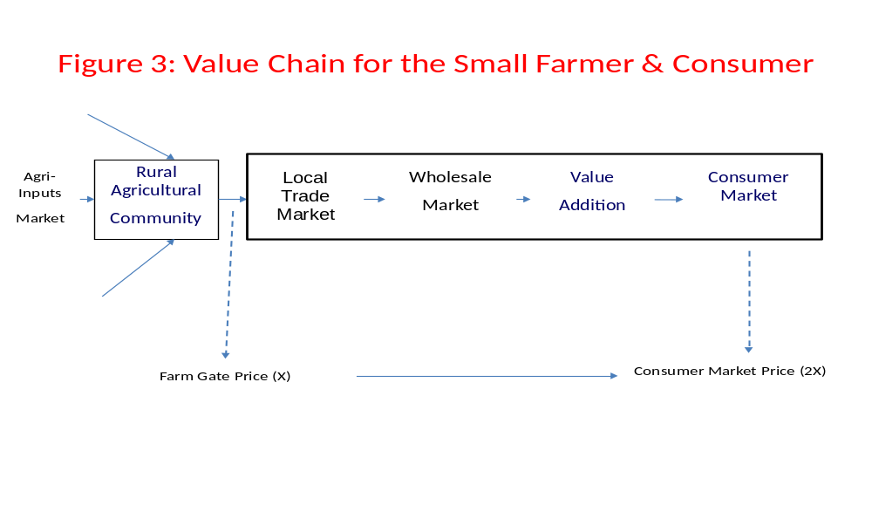
Given the various constraints of small producers, identifying the appropriate market landscape for marketing of their produce is probably a key to ensure better net income for the producers. The market landscape includes the variable of distance of a market from the point of production and the nature of market or customer/buyer that purchases the produce.

Distance of market from the point of production can be determined by the type of market. The type of market could be the village market, cluster level weekly market (haat), block level market, district level market, state level market, national market, international market, and global market. The distance of market within the cluster can be within 15 KM. Block market can be at a distance of 15-20 KM. The distance of the district market can be up to say 100 KM; whereas the distance of the state level market will be say up to 350 KM. Accordingly, the distance of national market, international market and global markets will be further away from the production cluster. Figure 4 depicts the market map for a cluster of producers. As the producer moves further away from the cluster of production, the institutional issues that the producers face becomes more and more complex and the cost of marketing increases. The marketing cost and the overall transaction cost of selling in far off market may increase so much that the net income for the small farmer may not increase even if the sales price is higher in far off market than the sale price in the local market.

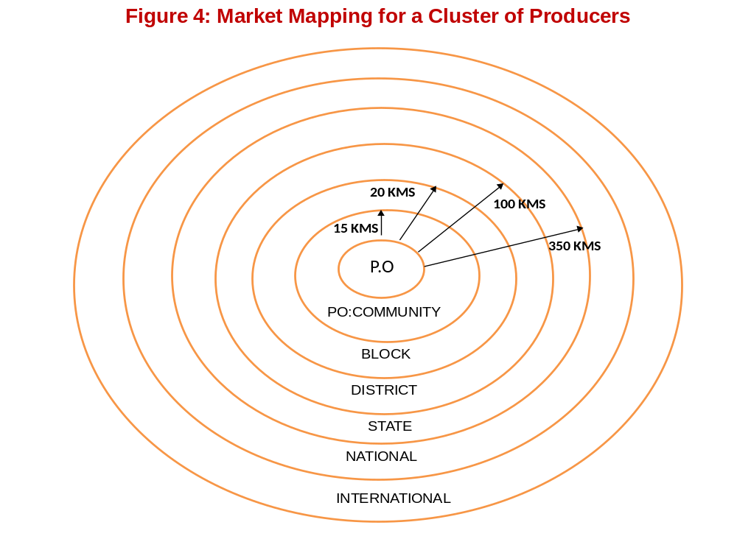

As the producer moves away from the local cluster to far away markets, the nature of market, customers and consumers that he/she will have to interact with could change. Marketing within the local cluster, the producer largely interact with the members of the same agricultural community. Further away, the producer will gradually have to interact with buyers and consumers in the semi-urban markets, urban markets, industrial markets, and global markets. Depending on type of market and nature of market (buyer/customer & consumer), perception and demand on product and service by the customer or consumer may greatly vary. In other words, with greater distance and customer/consumer different from the local cluster, the complexity for the producers increases.

The complexities associated within a product market could be due to variables such as demand, quality of product, quality of service, perception & value, behavior, competition (other competing suppliers, wholesale traders, awareness, supply conditions, product price, etc.). The complexities of these variables increases the producers travel further away from their own cluster of production to find new markets. These complexities could come on the way in the ability to bargain or negotiate better in favor of the producers in different market systems.

The more the producer moves away from the local conditions, the cost of selling increases to resolve the various complexities associated with operating in the distant markets. Different types of costs such as packaging cost, transportation cost, increased handling cost, storage cost, manpower cost, cost of seeking information, additional processing cost, cost of interest, cost of damage and losses, cost of institutional deficiencies, etc. While the cost of production remains the same, the cost of selling and marketing significantly increases as the producers move to far away markets. Unless, the per unit sale price realized in the far away market is much higher than the cost of production and the cost of selling and marketing in the far away markets, an increase in net income to the small producers may not be feasible.

There are a number of examples where the small producers have not increased their net income by their product being sold in far away markets. The farmers of Nava Jyoti Community Enterprise System have gained relatively better net income by selling their perishable vegetables and fruits within the local market. For most of the perishable crops, the producers in Nava Jyoti have made losses by selling in the district and state capital markets during the first three years of their organized marketing efforts. Similarly, the small weavers of Srikakulam district working with Fab India, a large international organization of weavers have not been getting their payment for over six months for the woven clothes that they have supplied to Fab India. While the local weavers with their limited skills and resource base would like to weave clothes that may meet demands of local market; for which they could get a good earnings, Fab India as the promoting organization has little support to facilitate weavers to weave clothes within their capacity and market them in the local markets.

4. Design of producer organization for internal consistency with the characteristics of the constituents who form the organization

While we seek synergy between the producers (internal) with the external market conditions; as explained in the previous section, synergy within the community is also important. Subsequently, systemic synergy across the ecology, individual producers, producer organization, and the external market is necessary to achieve highest level of efficiency in the system.

Within the rural agricultural settings, there are several asymmetries in terms socio-cultural, psychological, political, and economic factors. Local ecology is characterized by seasonal changes, bio-diversity, local culture, social specificities, specific micro-climatic conditions, local history and tradition, larger common properties, lesser private property with the majority of the population. Depending on the variations in the relationship of individuals in a community with the local ecology and institutions, the asymmetries among people within a community arises.

Unless, synergy or internal consistency is developed within the people in a community of cluster; the complexities for the producers/farmers in a community cannot possibly interact effectively with the better organized market system. A common institutional platform with common norms, rules and regulation could help minimize the variations or complexities within the members of a community. Formation of producer organization that could be community based, community owned and managed by the members from within the community could be a way out to resolves the minimizing the variations or complexities.

In other words, the better is the balance or synergy among the various levels viz., local ecology, individual members of the cluster, producer organization, and external market, the better is the sustainability of our basic environmental-social-economic unit, a cluster of few villages (say a Gram Panchayat). Please see Figure 5 for the variations at different levels of a basic unit.

Among the different levels in the chain of relationships as in Figure 4, changing the local ecology in a rural agricultural setting may be not advisable, and changing the market which is globalizing very fast is rather is impossible for the small producers. Given the nature of deep interrelations of production activities, culture and social life of agricultural communities, their problems and solutions are inter-related and hence their problems cannot be resolved at individual level unless their problems at are dealt with in a cluster with minimal ecological-social-economic variations. However, the design of the local institution of the people or the producer organization has to have synergy with the characteristics of the local ecology and the small producers of the cluster for it to be effective for the small producers. In other words, the design of producer organization needs to be internally consistent with the characteristics of the constituents who form the organization.

Figure 5:
Different Levels that is required to be balanced for effectively linking small producers to market - A System’s View

Local Ecology Small Producers Producer Organization Market Characteristics
Seasonal changes in a year

Specific micro-climatic conditions,

Bio-diversity & variety of crop production

Production of agricultural produce, horticultural produce, forest produce, local livestock & allied products

Local Culture & Social specificities

Local history and tradition,

Larger common properties,

Lesser private property with the majority of the population
Smaller Quantities of Produce
Larger variety in Product Basket
Lower value added products
Smaller Land Base

Lower Resource/Asset Base
Lower Capital Base
Limited Ownership (advantages)
Lower Credit based Transactions

Lower Competence Base:
Information-Knowledge-Technology Limited Formal Education
Simpler Management Skills
Lower Organizational capabilities

Design Variables

Size of Producer members

Scope of production and product basket

Technological appropriateness
(both agricultural production, agricultural inputs, & processing technologies)

Management methods, techniques & managerial pool for the organization

Ownership of the producer organization including contributions

Bulk Buyer
Large Volumes Transaction
Specialized Commodity Buyers
Better services in storage, packing, delivery, & year round supply
Negotiates for lowest commodity price
Demands long credit period
Better competence base in information knowledge, technology, organization & management

Retail Buyers
Higher Quality
Greater Product variety
Greater Price Elasticity
Good Packaging
Timely Delivery & Faster Service

Design of Internally Consistent Producer Organization:

The core variables on which organizations are designed are size, scope, technology, management and ownership (Nayak, 2008). All forms of organizations whether, private industrial organizations, state run enterprises, social enterprises or small community organizations can be differentiated based on the position of the above five variables. Please see Figure 6 that provides a spectrum of design variations ranging from small community informal organizations to large global private corporations.

Figure 6: Direction & Position of Firm Design Variables for Sustainability

Technically not Feasible Socially Unsustainable

Small Size Large
Multiple Scope Few
Small Capital Large
Low Technology High
Simple Management Complex
Dispersed Ownership of Resources Concentrated

Small Community Organization Firm Design Variables Multinational/Global Corporation

Source: Adapted from Nayak (2011)

Logically and empirically, we find that the existing small community informal organizations like the SHGs, CIGs, etc, are technically not feasible and the large global corporations are socially unsustainable. There have various arguments relating to the traditional large industrial organizations from the point of view of its appropriateness towards sustainability of a larger system.

While the business-as-usual model seeks control of both ownership and management, a universal model might have to allow for common ownership and common participation in the decision making process (Nayak, 2008, 2009, 2010, 2011). Sethi (1979, 1986) and Schumacher (1975) argued that instead of capital and technology, a process that clearly alienates the majority, the sustainable model probably have to seek equal proportion of capital of the co-workers of the enterprise and that each owner cum co-worker will have equal decision making power in the enterprise. As against economies of large scale of an individual enterprise, many small enterprises could produce enough for all (Schumacher, 1975). Using the theory of constraints (Goldratt, 1992), it has also been argued that the sustainability of a system could be achieved if the weakest person in the society can be sustained. The concerns for developing appropriate business models to fit the context of the base of the pyramid have been raised by many including Ricart, et al (2004).

Based on the action research on the design issues of producer organization and sustainable community system, we share here some of the findings on optimal design positions of key variables of a producer organization.

Considering the concept of individual, the basic unit within the capitalistic framework, as an abstract concept from sustainability perspective, this approach takes the family as the unit of analysis; a realistic and holistic concept. Hence sustainability of the producer-family is the prime concern and not the enterprise per say. The concept of village seems small and sub-optimal and hence the community (consisting of a few villages) as a relevant operational unit from the point of view of optimal size of ecology; where the people can share and exchange goods, services, joys and sorrows by cooperating, complementing, and supporting each other.

Size indeed plays a significant role on the level of participation and nature of democracy at the grass root level. As the size of a system increases, the distance between the actors within the system increases; which tends to reduce the participation among the various actors within the system. With increasing size, the complexities within the system also increase. Hierarchy becomes a necessity to maintain order in the system. As a result an indirect representation within the system evolves and direct democratic processes gradually reduce. As the distance between actors increases, the rules and procedures take over, control mechanisms begin to guide the processes and the human element of the actors in the system distances from the operations.

While growth in size in terms of sales and revenue turnover form the basis of a traditional firm, the community enterprise system based on agricultural and allied products could be designed for an optimal size in terms operational size of the community and the number of producer members. For geographical contiguity, ease of communication among the producer members, transport and logistics, the members could be drawn from the villages within the ecology of a Gram Panchayat (GP).

On scope, while the traditional firms focus on a few products or services for higher efficiency of the firm, the community enterprise system will seek economies of scope on the produces from the small producers or farmers. Aggregation of small surplus produce will be important in the early stages of the community enterprise system. Given their small land holdings, smaller resource base, and the environment friendly attitude, the marginal producers can only produce small quantities of items. The surplus after consumption by the family is still smaller. Further, the production relationship is linked to the natural resources and the seasons of the year. Therefore, they are best suited to produce a variety of items during the different seasons of the year. However, every ecological system has a variety of resources for sustaining its inhabitants and hence adopting greater scope of produce for community enterprise system appears to be viable. The issues relating to size and scope with regard to industrial organizations have been discussed over the years (Krugman, 1980, 2008, Mason, 1949).

Technology in the given context could mean that the process of farming, the type of farm inputs or the type of farm machinery being used and the processing technology for value addition activities. Technology intensity may be relevant in industries where the issues of indivisibility and technological compatibility could arise. However, given the nature of production and consumption patterns in agriculture, farm produce, and the marginal farmers, technology intensity may not be appropriate. While intervention with appropriate technology would be effective in the complex, diverse and risk prone (CDR) agricultural settings, the current nature of technological interventions have been found to be largely deficient. (Chamber, 2005)

Technology intensity would invariably exclude the marginal producers from the production system. Instead of being technology intensive as in traditional firms, appropriate technology with improvisation of local technology wherever available could be used for achieving better efficiency of the community. Leveraging the technical capabilities of the people and creating a mechanism to complement the local knowledge and capability would help. Adapting appropriate and people friendly technologies could enhance the efficiency of the community enterprise system. Indeed, the age old tradition of integrated agriculture following organic principles viz., on farm seed production, biomass and organic input generation, and in-situ water and soil conservation have been rediscovered to be the most sustainable agricultural methods.

The size and source of capital employed in the proposed community enterprise should be carefully chosen. Optimal levels of capital should be employed as capital intensity would again exclude majority of the people in rural community because of the high asymmetry of resource base in the community. Professional guidance to organize in the first few years and untied seed capital from the Government to the community enterprise would substantially remove the capital asymmetry among the marginal producers and help put the community enterprise system into action.

With regard to ownership and management control, the community enterprise system should not only be community owned and managed but also be based in the community and not far away from its producer-members. Being aware of these institutional issues and other problems in a village setting, the proposed enterprise system should also be appropriately paced such that the people in the community can appreciate and accept the processes to form and develop their enterprise system for themselves.

While community enterprise will be owned by the primary producers, it will be managed by a team of local community workers and facilitators for marketing, logistic, book keeping, value addition, planning and coordination. In other words, based on the initial action research experiences, for a sustainable community enterprise system, the enterprise system has to be community based, community paced and community owned and operated by local community workers.

The producer organization would not only engaging in marketing of surplus produce, but also serve as single window to provide other services and support such as community banking, integrated low cost agriculture, local value addition of agricultural produce, integrate with other income generating activities, as well as converge resources for community health, primary education, and basic rural and village infrastructure. Please see Figure 7 for the design variables and the structure of operation.
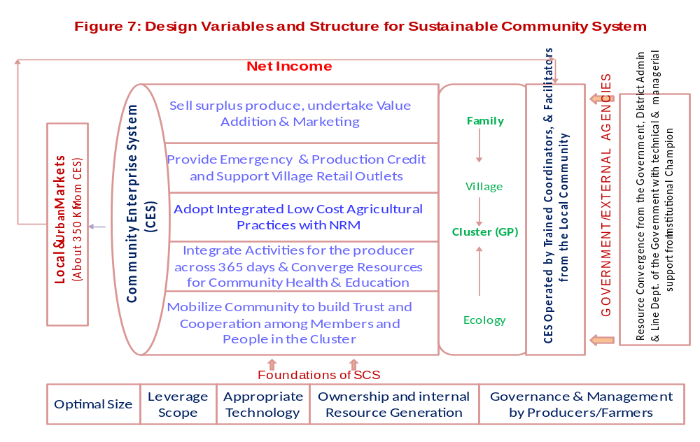

Source: Nayak, Amar KJR. 2011. Optimizing Asymmetries for Sustainability: Design Issues of Producer Organization, National Seminar on Productivity in Indian Agriculture, College of Agricultural Banking, Pune, Reserve Bank of India, September 2-3, 2011
Reference:

Goldratt, E.M. and Jeff Cox. 1992. The Goal: A Process of ongoing Improvement, North River Press.
Krugman, P. 2008. “New Trade”, “new geography” and the troubles of manufacturing. Nobel Memorial presentation, December 8, 2008
Krugman, Paul. 1980. 'Scale economies, product differentiation, and the pattern of trade'. American Economic Review 70, pp. 950-59.
Mason, E.1949. ‘The current state of monopoly problem in the U.S.’ Harvard Law Review, 62, pp. 1265-1285
Nayak, Amar K.J.R. 2008. Participation and Development Outcomes in a top-down institutional set-up: Empirical evidences from the KBK districts of India, 20th Annual Convention-2008, Association of Indian Management Schools, Mumbai,
Nayak, Amar K.J.R. 2008. Variables towards Non Competitive Strategies - A Perspective, Creativity, vol.1, 2008
Nayak, Amar K.J.R. 2009. Variables towards Non Competition and Sustainable Strategies, IAJBS International Conference, XLRI, Jamshedpur, June 2009
Nayak, Amar KJR. 2010, Participation and Development Outcomes: Evidences from the Poor Districts of India, Journal of Management & Public Policy, vol. 1, No.2
Nayak, Amar K.J.R. 2010. Indian Multinationals: The Dynamics of Explosive growth in a Developing Country Context, Palgrave Macmillan, UK & USA
Nayak, Amar KJR. 2011. Optimizing Asymmetries for Sustainability: Design Issues of Producer Organization, National Seminar on Productivity in Indian Agriculture, College of Agricultural Banking, Pune, Reserve Bank of India, September 2-3, 2011
Penrose, Edith. 1995. The Theory of the Growth of the Firm, Third Edition, Oxford University Press, New York.
Ricart, J.E., Enright, M.J., Ghemawat, P., Hart, S.L., & Khanna, T. 2004. New frontiers in international strategy, Journal of International Business Studies, 35, 175-200
Schumacher E. F. 1975. ‘Small is Beautiful’, Sphere Books Limited, London.
Sethi, J.D. 1979. ‘Gandhi Today’, 2nd Edition, Vikas Publishing House Pvt. Ltd., New Delhi.
Sethi, J.D. 1986. ‘Trusteeship and the Crisis in Economic Theory’, in Trusteeship: The Gandhian Alternative, Gandhi Peace Foundation.
Wernerfelt, Birger. 1984. ‘A resource-based view of the firm’, Strategic Management Journal, Vol.5, 171-180

Professor of Strategy and NABARD Chair Professor, Xavier Institute of Management, Bhubaneswar, Orissa, India, Email: amar@ximb.ac.in
Many of the ideas discussed in this Working Paper have evolved over time through my engagement in teaching the course on Non Competitive Strategies at XIMB and my involvement in Action Research projects of FAO-UNO and NABARD-India. My engagement with the work of Sustainability Trust with my wife, Sashmi has been the ground for learning and advancing the thoughts and actions. The National Bank for Agriculture and Rural Development, Government of India, has been the prime financial supported of the Action Research on above sustainable development model in the rural agricultural settings. Setting up the NABARD Chair Unit in XIMB further strengthened the research. Without this financial and administrative support the action research would not have been possible. The other supporters have been the Xavier Institute of Management, Bhubaneswar, Order of Discalced Carmelite, Nuagada and Sustainability Trust, Bhubaneswar. A number of co-learners, well wishers, my colleagues especially Prof. Jeevan Arakal, friends, and the community in Nava Jyoti Kendra, Nuagada area and many others have added to the development of the ideas in this paper. My gratitude and appreciation to all involved for their contributions in different ways. The grant support from Rabo Bank Foundation from March 2011 has helped the action research to operate on a commercial scale. This support has been timely and critical to take the action research to a higher level of operation and to understand the various issues of sustainability of the model. I would like to sincerely thank and express my deep gratitude to Rabo Bank Foundation for its kind support and understanding.

